CPSC 1100 - 04 Spring 2020

**Due Date: Wednesday, April 15, 2020 Points: 200**

# Project Title:

Truck weight scale GUI.

# Team Members:

Robert Hall, Joseph Edwards, Robert Burton

# Purpose:

A GUI to have users enter information about the weight of their vehicle, and it calculates the speed based on our calculations. The user can select previous created people with vehicles to view records. The GUI will also have functions to add user, remove all from list, display current time, and view previous records and other information.

# Scope of Work ( 2 months = 8 weeks)

Scope of work will consist over the course of two months,

Requirements:

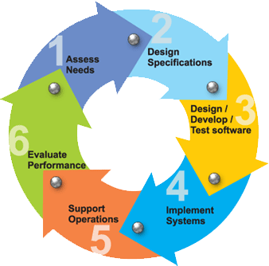

This is a team project.

This project is 200 points and will require you to:

* Create a java program in BlueJ illustrating the solution to the business/technology problem.
* You must use arrays or array lists.
* You must use a switch statement.
* You must use repetition structure.
* Your program should be interactive.
* You must use try catch block to capture bad input data.
* Present a summary of your report using PowerPoint and participate in discussion.

To complete this project successfully, please read all project sectionscarefully. For each task in your project, divide your work equally among team members and keep a track of your progress. Use draw.io to create your UML diagrams. Sample is listed below:

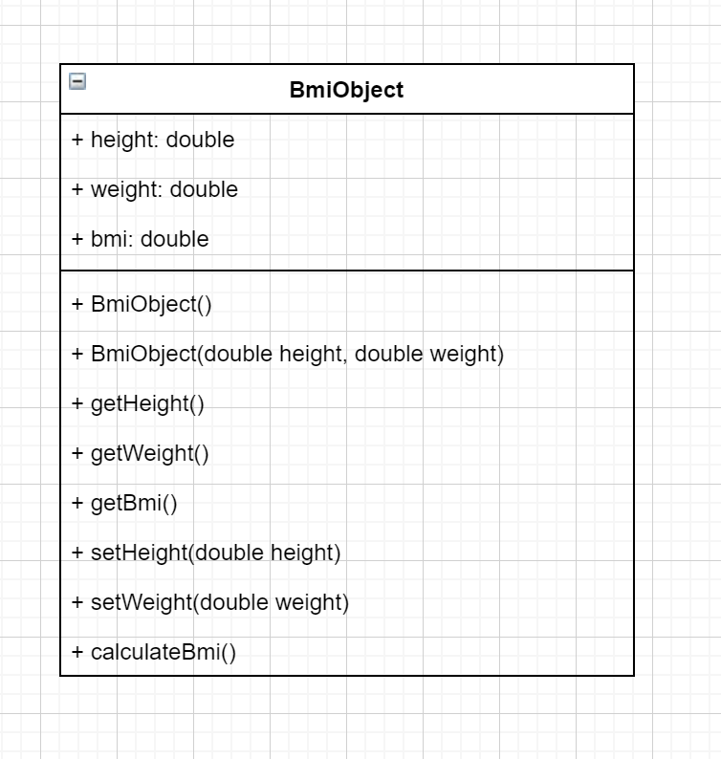

# Timeline

Week of 2/17/2020: Currently working on basic class structures and implementing basic GUI elements including buttons and lines. Basic class structures will be used along with GUI elements to add functionality.

Week of 2/24/2020:

# Code

The project helps you practice the following skills that are essential to your success in this course and professional life beyond school:

* Break down problems by using Software Development processes.
* Understanding of how to code robust programs and reusable code.
* Apply advanced programming concepts.
* Revise fundamental concepts of Object-Oriented Programming and Design
* Create a program illustrating the solution to a business problem.

# Knowledge

This project will also help you to become familiar with the following important content knowledge in this discipline:

1. Classes and objects
2. Instance and local variables
3. Constructors and methods
4. Instantiation of Classes
5. Overloading
6. Encapsulation
7. Control statements
8. Loops, arrays, and arraylists

# Task

In this project, you are going to develop software implementing the topic of your choice ( PG 13 content)(examples : shopping cart, restaurant menu billing, scoring for a baseball game, scoring a golf game, board games etc.)

**Step 1:** Determine the inputs and outputs.

**Step 2:** Break down the project into smaller classes.

**Step 3:** Describe each subtask in a class.

**Step 4:** Test your pseudocode by working a problem.

**Step 5:** write your computer program.

**Step 6:** Compile and test your program.

**Step 7:** Document using Javadoc comments.

Submit your project and presentation on canvas.

# Criteria for Success

* The final project should include the PowerPoint presentation, generated Javadoc and the running program.
* The presentation should include each phase with clear description.
* During presentation, every team member should be able to explain any part of the project.
* In the program, each class should be written in separate files, naming convention should be implemented, and relationship defined correctly.

# Grading

|  |  |
| --- | --- |
| Task | Allocated Mark |
| **Problem Solving Understand the problem, develop and describe an algorithm, and test it with simple input** | 50 |
| **Class Design Following naming conventions, proper indentations, encapsulation, Class Structure** | 25 |
| **Javadoc Thoroughly commenting the behavior of classes and methods, using the standard documentation comments** | 25 |
| **Tester Class** | 50 |
| **Presentation** | 25 |
| **Peer Review** | 25 |
| **Total** | 200 |